**Timeless Warmth with Elegant Wooden Mirrors**

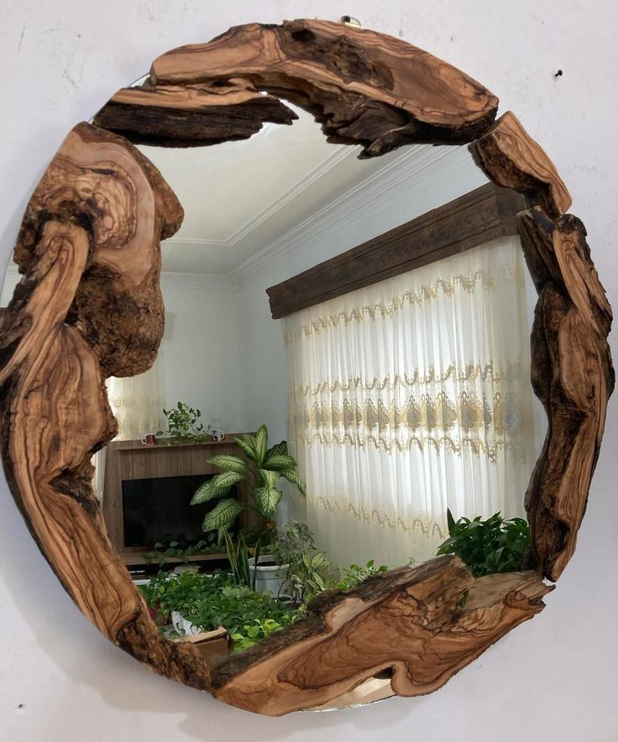

Wooden Mirrors bring a sense of natural warmth and authenticity to any interior. Their organic textures and rich finishes add character and depth, making them a perfect choice for spaces that aim to feel cozy, grounded, and timeless.

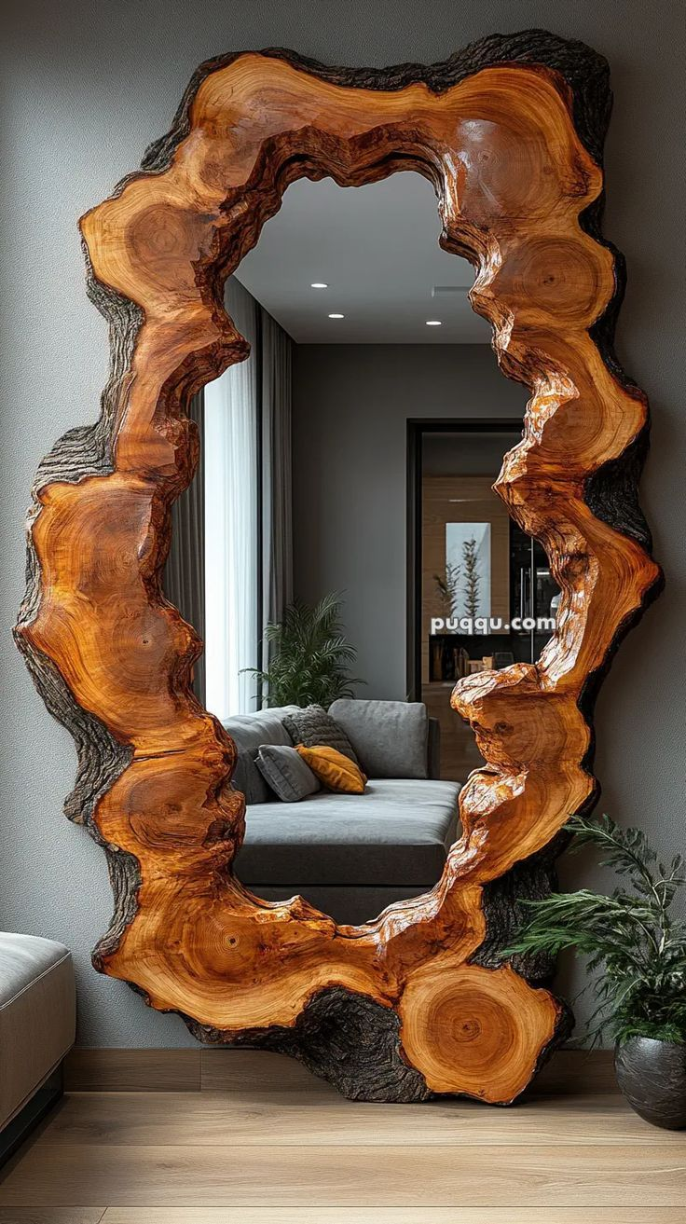

Whether crafted from oak, walnut, teak, or reclaimed wood, each wooden mirror carries its own unique grain and personality. From rustic farmhouse charm to sleek, modern minimalism, wooden frames adapt effortlessly to a

variety of décor styles.

These mirrors are not just reflective surfaces — they’re pieces of art that highlight craftsmanship and bring the beauty of nature indoors. Perfect for living rooms, bedrooms, entryways, or bathrooms, they complement both neutral palettes and vibrant interiors.

Choose a wooden mirror to add warmth, texture, and timeless appeal to your home — a perfect blend of function and natural elegance.